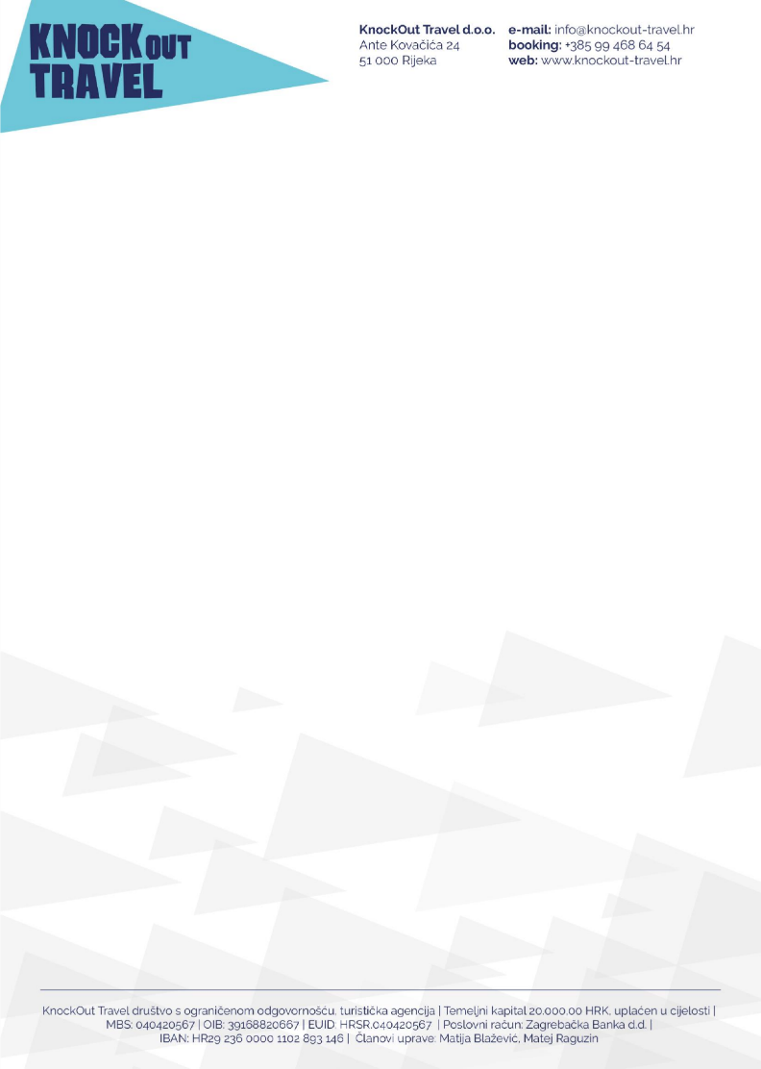

**SUGLASNOST**

SUGLASAN/SUGLASNA SAM S TIME DA SE MOJ SIN/KĆER

(

ime i prezime)

PRIJAVLJUJE NA

**KNOCKOUT SNOW FESTIVAL 2023. (31.12.-07.01.2023.)**

DATUM I MJESTO

________________________________

IME I PREZIME RODITELJA

________________________________

POTPIS

________________________________